**CHAPTER 1**

**INTRODUCTION**

**1.1 OVERVIEW**

The design and implementation of a comprehensive student information system and user interface to replace the current paper records is proposed in this project can be able to access all aspects of a student’s academic progress through a secure, online interface embedded in the website. The system utilizes user authentication, displaying only information necessary for an individual’s duties.

Additionally, each sub-system has authentication allowing authorized users to create or update information in that subsystem. All data is thoroughly reviewed and validated on the server before actual record alteration occurs. All data is stored securely on SQL servers managed by the administrator and ensures highest possible level of security. The system features a complex logging system to track all user access and ensure conforming by the giving username and password.

Previously, faculty worked heavily on paper records for this initiative on collecting the details of students regarding placement purpose. Paper records are difficult to manage and track. The physical exertion required to retrieve, alter, and re-file the paper records are all non-value added activities. This system provides a simple interface for the maintenance of student information. It can be used by educational institutes or colleges to maintain the records of students easily.

Achieving this objective is difficult using a manual system as the information is scattered, can be redundant and collecting relevant information may be very time consuming. All these problems are solved using online Student Information Management System(SIMS). It facilitates online registration and profile creation of student’s automating the record generation process in an educational institution.

**1.2 OBJECTIVES**

The main objective of this project is to maintain the details of students and the purpose of Student Information Management System is to get an understanding of how the student’s record is maintained. This Student Information Management System is based on identification of some key qualities in the document and their relations. With the understanding of the structure and content of key quality documents, it will help to reduce the duplication and save more time.

The objectives are

* Giving online interface for students and faculty members.
* Expanding the effectiveness of college record administration.
* Abatement time needed to access and convey students’ records.
* To make the framework more secure.

**CHAPTER 2**

**LITRATURE SURVEY**

**2.1 DEVELOPMENT OF STUDENT INFORMATION SYSTEM**

N.M.Z.Hashim and S.N.K.S.Mohamed [1] proposed an alternative on development on student information system. For this purpose, many organizations spend budget to buy a good system in order to have a reliable system to be operated in their organization. Many systems that invented are focused on the user friendly element e.g. easy to print out the document, available in cell phone and easy to access from anywhere. The proposed project developed student information that be used in Faculty of Electronics & Computer Engineering (FKEKK) and is known as the Student Information System (SIS).

As guidance for this project development, Rapid Application Design (RAD) methodology has used. As the conclusion, the software was fully functional and achieved the objectives. This system contributed a new knowledge to the student information system and gives the ease to the user for making arrangement or scheduling the student matter.

**2.2 WEB BASED STUDENT INFORMATION MANAGEMENT SYSTEM**

S.R.Bharamagoudar, et al., [2] proposed a simple interface for maintenance of student information. It can be used by educational institutes or colleges to maintain the records of students easily. The creation and management of accurate, up-to-date information regarding a student’s academic career is critically important in the university as well as colleges. Student information system deals with all kind of student details, academic related reports, college details, course details, curriculum, batch details, placement details and other resource related details too.

It tracked all the details of a student from the day one to the end of the course which can be used for all reporting purpose, tracking of attendance, progress in the course, completed semesters, years, coming semester year curriculum details, exam details, project or any other assignment details, final exam result and all these will be available through a secure, online interface embedded in the college’s website.

**2.3 A FRAMEWORK FOR WEB BASED STUDENT RECORD MANAGEMENT SYSTEM USING PHP**

SaurabhWalia and SatinderjitKaur Gill [3] proposed a straight forward interface to support of student data. It might be utilized by instructive universities or colleges to keep up the records of students effectively. The creation and administration of error less, exceptional data in regards to a student' scholarly profession is discriminatingly paramount in the colleges and in universities. Student information system manages all sorts of student details, academic related reports, college details, fee details, results, batch details, attendance details and other resource related details too.

This tracks all the details of a student from very first moment to the end of the course which could be utilized for all reporting purpose, tracking of attendance, progress in the study, completed semesters, years, coming semester year curriculum details, fee details, project or any other assignment details, final exam result and all these will be available through a secure, online interface embedded in the college’s Student Record Management System.

**2.4 STUDENT INFORMATION MANAGEMENT SYSTEM**

Manisha K, et al., [4] proposed an interface to maintain the student’s data. SIMS is used to manage any student related information within a particular school or college or a university. This is mainly used by student’s in-order to view and access the information regarding college which comprises of notifications, placement details, exam timetables etc.

Any college related information such as events, notifications, updating or deleting of student records could be done easily and securely using this web based online system. SIMS is a repository of data collection, data processing, data analysis and data reporting. Admin provides secured logins to each and every section such as placement section, exam section, faculty and also to each and every individual student

**2.5 STUDENT MANAGEMENT SYSTEM – A SURVEY**

Krithi P and Dr M Ramakrishna [5] proposed an essential way for an institution or to a college or to a university, which utilizes computer, also which reduces manpower. Student Management System manages several student details like USN, student attendance, internal assessment marks, parent name, phone number, email-id, date-of-birth, class, sex etc. The goal of evolving this application is to induce the report regarding attendance at the completion of the conclave or at the middle of the conclave. Also it is possible to get the average of internal assessments and it is easy to get the report at the end.

Student’s and faculty’s details are uploaded by the admin. The user will give username and passwords to the respective. Finally student can only view his details, he can take the report. Student Management System has four modules. Initially admin will login, login module. Later he is going to upload the details of student, called student data module which has the functionalities like searching, inserting, updating and deleting the student data. At the end of the session report will be generated, called report module which is generated in the pdf format.

**CHAPTER 3**

**SYSTEM ANALYSIS**

**3.1 EXISTING SYSTEM**

System Analysis is a detailed study of the various operations performed by a system and their relationships within and outside of the system. Here the key question is- what all problems exist in the present system? What must be done to solve the problem? Analysis begins when a user or manager begins a study of the program using existing system.

During analysis, data collected on the various files, decision points and transactions handled by the present system. The commonly used tools in the system are Data Flow Diagram, interviews, etc. Training, experience and common sense are required for collection of relevant information needed to develop the system. The success of the system depends largely on how clearly the problem is defined, thoroughly investigated and properly carried out through the choice of solution. A good analysis model should provide not only the mechanisms of problem understanding but also the frame work of the solution. Thus it should be studied thoroughly by collecting data about the system. Then the proposed system should be analysed thoroughly in accordance with the needs.

System analysis can be categorized into four parts.

* System planning and initial investigation
* Information Gathering
* Applying analysis tools for structured analysis
* Feasibility study
* Cost/ Benefit analysis.

In the current system we need to keep a number of records related to the student and want to enter the details of the student and the marks manually. In this system only the teacher or the school authority views, verifies the mark of the students and they enter the details of the students. This is time consuming and has much cost.

* + 1. **DISADVANTAGE OF EXISTING SYSTEM**
* The data can be easily leaked.
* There is no efficient technique to safe guard the users of phishing websites.

**3.2 PROPOSED SYSTEM**

The proposed system will have the provision for adding the details of the students by staff. Another advantage of the system is that it is very easy to edit the details of the student and delete a student when it found unnecessary. The marks of the student are added in the database. The proposed system has several advantages

* User friendly interface
* Fast access to database
* Less error
* More Storage Capacity(250GB)
* Search facility
* Look and Feel Environment

All the manual difficulties in managing the student details in a school or college have been rectified by implementing computerization.

In this case, using a local server called XAMPP. For, Frontend HTML, CSS, JavaScript and backend will be PHP and MySQL.

The following three should be taken in to consideration:

1. Frontend

2. Backend

3. Server

**Frontend**

The front-end is everything involved with what the user sees (GUI), including design and some languages like HTML and CSS. With continuing development for mobile devices, such as smart phones and tablets, designers need to ensure that their site comes up correctly in browsers on all devices. This can be done by creating a responsive web design using style sheets in CSS.

Performance goals are chiefly concerned with render time, manipulating the HTML, CSS, and JavaScript to ensure that the site opens up quickly**.**

**Backend**

The back-end, or the "server-side", is basically how the site works, updates and changes. This refers to everything the user can't see in the browser, like databases and servers.

The code they write communicates with the server and then tells the browser what to use from the database.

**Server**

XAMPP stands for Cross-Platform (X), Apache (A), MySQL (M), PHP (P) and Perl (P). It is a simple, lightweight Apache distribution that makes it extremely easy for developers to create a local web server for testing purposes. It can set up a web server – server application (Apache), database (MySQL), and scripting language (PHP) – is included in a simple extractable file. XAMPP is also cross-platform, which means it works equally well on Linux, Mac and Windows. Since most actual web server deployments use the same components as XAMPP, it makes transitioning from a local test server to a live server is extremely easy as well. Web development using XAMPP is especially beginner friendly XAMPP is a small and light Apache distribution containing the most common web development technologies in a single package. Its contents, small size, and portability make it the ideal tool for students developing and testing applications in PHP and MySQL. XAMPP is available as a free download in two specific packages: full and lite. While the full package download provides a wide array of development tools, this article will focus on using XAMPP Lite which contains the necessary technologies that meet the Ontario Skills Competition standards.

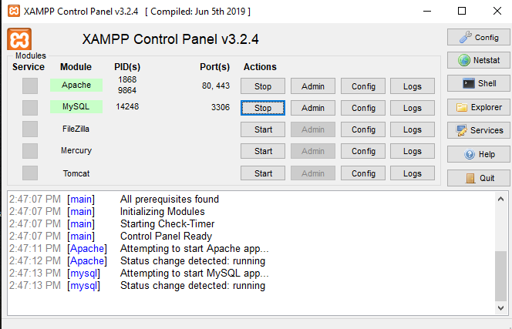

**Figure 1: XAMPP Control Panel**

Figure 1 shows the XMAPP control panel and XAMPP has four primary components:-

**1. Apache:** Apache is the actual web server application that processes and delivers web content to a computer. Apache is the most popular web server online, powering nearly 54% of all websites.

**2. MySQL:** Every web application, howsoever simple or complicated, requires a database for storing collected data. MySQL, which is open source, is the world’s most popular database management system. It powers everything from hobbyist websites to professional platforms like WordPress.

**3. PHP:** PHP stands for Hypertext Preprocessor. It is a server-side scripting language that powers some of the most popular websites in the world, including WordPress and Facebook. It is open source, relatively easy to learn, and works perfectly with MySQL, making it a popular choice for web developers.

**4. Perl:** Perl is a high-level, dynamic programming language used extensively in network programming, system admin, etc. Although less popular for web development purposes, Perl has a lot of niche applications.

**3.2.1 ADVANTAGES OF THE PROPOSED SYSTEM**

* Data can be monitored and easily updated.
* Reports can be easily generated.

**CHAPTER 4**

**SYSTEM SPECIFICATION**

**4.1 HARDWARE REQUIREMENTS**

System : Intel, AMD Hardware

Hard Disk : 250 GB.

Monitor : 15 VGA Colour

Mouse : Optical.

Ram : 1 GB

**4.2 SOFTWARE REQUIREMENTS**

Operating system : Platform Independent

Coding Language : HTML,CSS,JS,PHP

Database : My-SQL

Server : Apache

IDE : Notepad++

**4.3 FUNCTIONAL REQUIREMENTS**

The functional requirements of the system are to the implement the solution for finding the student details and information in the Student information and management system.

**1. Input / Output**

The user login and select the type of module and analysis their needs.

**2. Processing**

The information regarding student details are retrieved from the database.

**3. Storage Requirements**

The information will be retrieved from the database.

**4. Control Requirements**

Alerts when any errors are there and when any of the field is not selected.

**4.4 SOFTWARE ENVIRONMENT**

**4.4.1 PHP TECHNOLOGY**

PHP is a server-side scripting language designed for web development but also used as a general-purpose programming language. PHP is now installed on more than 244 million websites and 2.1 million web servers. Originally created by RasmusLerdorf in 1995, the reference implementation of PHP is now produced by The PHP Group. While PHP originally stood for Personal Home Page, it now stands for PHP: Hypertext Preprocessor, a recursive backronym.PHP code is interpreted by a web server with a PHP processor module, which generates the resulting web page: PHP commands can be embedded directly into an HTML source document rather than calling an external file to process data. It has also evolved to include a command-line interface capability and can be used in standalone graphical applications.

PHP is free software released under the PHP License. PHP can be deployed on most web servers and also as a standalone shell on almost every operating system and platform, free of charge**.**

## 4.4.2 MySQL

MySQL ("My S-Q-L", officially, but also called "My Sequel") is (as of July 2013) the world's second most widely used open-source relational database management system(RDBMS). It is named after co-founder Michael Widenius daughter, My SQL phrase stands for Structured Query Language. The MySQL development project has made its source code available under the terms of the GNU General Public License, as well as under a variety of proprietary agreements. MySQL was owned and sponsored by a single for-profit firm, the Swedish company MySQL AB, now owned by Oracle Corporation .MySQL is a popular choice of database for use in web applications, and is a central component of the widely used LAMP opens source web application software stack (and other 'AMP' stacks). LAMP is an acronym for "Linux, Apache, MySQL, Perl/PHP/Python." Free-software-open source projects that require a full-featured database management system often use MySQL. For commercial use, several paid editions are available, and offer additional functionality.

### 4.4.3 HTML and CSS

Hyper Text Markup Language is the main language for creating web pages and other information that can be displayed in a web browser.HTML is written in the form of HTML elements consisting of tags enclosed in angle brackets like<html>, within the web page content.

HTML tags most commonly come in pairs like <h1> and </h1>, although some tags represent empty elements and so are unpaired, for example <img>. The first tag in a pair is the start tag, and the second tag is the end tag (they are also called opening tags and closing tags). In between these tags web designers can add text, further tags, comments and other types of text-based content.

The purpose of a web browser is to read HTML documents and compose them into visible or audible web pages. The browser does not display the HTML tags, but uses the tags to interpret the content of the page.HTML elements form the building blocks of all websites. HTML allows images and objects to be embedded and can be used to create interactive forms. It provides a means to create structured documents by denoting structural semantics for text such as headings, paragraphs, lists, links, quotes and other items. It can embed scripts written in languages such as JavaScript which affect the behaviour of HTML web pages.

**Cascading Style Sheets (CSS)** is a style sheet language used for describing the look and formatting of a document written in a markup language, to style web pages and interfaces written in HTML and XHTML. The language can be applied to any kind of XML document, including plain XML, SVG.

CSS is a cornerstone specification of the web and almost all web pages use CSS style sheets to describe their presentation.CSS is designed primarily to enable the separation of document content from document presentation, including elements such as the layout, colours, and fonts. This separation can improve content accessibility, provide more flexibility and control in the specification of presentation characteristics, enable multiple pages to share formatting, and reduce complexity and repetition in the structural content (such as by allowing for table less web design).

CSS can also allow the same markup page to be presented in different styles for different rendering methods, such as on-screen, in print, by voice (when read out by a speech-based browser or screen reader) and on Braille-based, tactile devices. It can also be used to allow the web page to display differently depending on the screen size or device on which it is being viewed. While the author of a document typically links that document to a CSS file, readers can use a different style sheet, perhaps one on their own computer, to override the one the author has specified. However if the author or the reader did not link the document to a specific style sheet the default style of the browser will be applied.

**4.4.4 JavaScript**

JavaScript is a dynamic computer programming language. It is most commonly used as part of web browsers, whose implementations allow client-side scripts to interact with the user, control the browser, communicate asynchronously, and alter the document content that is displayed. It is also being used in server-side programming, game development and the creation of desktop and mobile applications.

JavaScript is a prototype-based scripting language with dynamic typing and has first-class functions. Its syntax was influenced by C. JavaScript copies many names and naming conventions from Java, but the two languages are otherwise unrelated and have very different semantics.

The key design principles within JavaScript are taken from the self and Scheme programming languages. It is a multi-paradigm language, supporting object-oriented, imperative, and functional programming styles. The application of JavaScript to use outside of web pages—for example, in PDF documents, site-specific browsers, and desktop widgets is also significant.

**4.5 UML Diagrams**

**4.5.1 Introduction**

Design is the first step in the development phase for an engineered product or system. Design is the place where quality is fostered in software development. Design is the only way that can accurately translate a user's requirements into a finished software product or system.

**4.5.2 UML Diagrams**

**Use Case Diagram**

**Figure 2: Use Case Diagram for Admin**

**Figure 3: Use Case Diagram for Staff**

Figure 2 and 3 shows the representation of a user's interaction with the system that shows the relationship between the user and the different use cases in which the user is involved and displays the relationship between actors and use cases.

**State Diagram**

**Figure 4: State diagram**

Figure 4 shows the sequence of states that an object of an interaction goes through during its life in response to received stimuli, together with its responses and actions.

**Deployment Diagram**

**Figure 5: Deployment diagram**

Figure 5 shows architecture of Student Information Management System to deployment targets of Administrator, staff, Student details and Accessing Database.

**4.6 DATABASE DESIGN**

The general theme behind a database is to handle information as an integrated whole. A database is a collection of interrelated data stored with minimum redundancy to serve many users quickly and efficiently. The general objective is to make information access easy quick and flexible for user. In database design several objectives are considered.

**Control Redundancy**

Redundant data occupies space and therefore, is wasteful. If versions of the data are in different phases of updating the system often gives conflicting information. A unique aspect of database design is storing only once, which controls redundancy and improves system performance.

# 4.6.1 TABLE STRUCTURES

### Student Table

|  |  |  |
| --- | --- | --- |
| **Field Name** | **Data Type** | **Constraint** |
| Id | int | Primary Key |
| reg_no | int |  |
| Name | varchar |  |
| father_name | varchar |  |
| Dob | date |  |
| gender | varchar |  |
| Contact | number |  |
| Email | varchar |  |
| address | text |  |
| department | varchar |  |
| sec | varchar |  |
| Image | longblob |  |

**Table 1: Database design for Student**

**UAD Table**

|  |  |  |
| --- | --- | --- |
| **Field Name** | **Data Type** | **Constraint** |
| Username | varchar |  |
| Password | varchar |  |

**Table 2: Database design for UAD**

**Academic Table**

|  |  |  |
| --- | --- | --- |
| **Field Name** | **Data Type** | **Constraint** |
| Id | int | Primary Key |
| reg_no | int |  |
| Name | varchar |  |
| departmet | varchar |  |
| percentage_sslc | float |  |
| percentage_hsc | float |  |
| percentage_sem 1 | float |  |
| percentage_sem 2 | float |  |
| percentage_sem 3 | float |  |
| percentage_sem 4 | float |  |
| percentage_sem 5 | float |  |
| percentage_sem 6 | float |  |
| percentage_sem 7 | float |  |
| percentage_sem 8 | float |  |
| percentage_cgpa | float |  |
| current_arrear | varchar |  |
| history_arrear | varchar |  |

**Table 3: Database design for Academic**

**4.6.2 DATA FLOW DIAGRAM**

The Data Flow Diagram (DFD) is also called as bubble chart. It is a simple graphical formalism that can be used to represent a system in terms of the input data to the system, various processing carried out on these data, and the output data is generated by the system.

* A  DFD is a graphical representation of the "flow" of data through an information system, modeling its process aspects. Often they are a preliminary step used to create an overview of the system which can later be elaborated.
* A DFD shows, what kind of data will be input to and output from the system, where the data will come from and go to, and where the data will be stored.

**Figure 6: Data Flow Diagram**

**4.6.3 Interface Design**

The purpose of interface design is to determine about the layout of the system and to make sure that this layout is suitable with user requirement. A good design attracts the users without confusions about each function of the system. For instance, the developer also needs to concern about user-friendly interface during designing phase. This system is easy to use.

**4.6.3.1 Button**

There are a few buttons which been prepared for the user’s usage such as view, delete and search button. All these buttons have their own functions.

**4.6.4 Coding Design**

Structured Query Language (SQL) is a standard computer language for relational database management and data manipulation. SQL is used to query, insert, update and modify data. Most relational databases support SQL, which is an added benefit for database administrators (DBAs), as they are often required to support databases across several different platforms. SQL code is divided into four main categories:

* Queries are performed using the ubiquitous yet familiar SELECT statement, which is further divided into clauses, including SELECT, FROM, WHERE and ORDER BY.
* Data Manipulation Language (DML) is used to add, update or delete data and is actually a SELECT statement subset and is comprised of the INSERT, DELETE and UPDATE statements, as well as control statements.

Eg. INSERT INTO `mark` (`MID`, `REGNO`, `NAME`, `DEPT`, `SSLC`, `HSC`, `SEM 1`, `SEM 2`, `SEM 3`, `SEM 4`, `SEM 5`, `SEM 6`, `SEM 7`, `SEM 8`, `CGPA`, `CUR AR`, `HIS AR`) VALUES

(1, '16104001', 'ADITYA PAREEK V', 'CSE', 86.4, 68.83, 7.3, 6.74, 7.29, 6.76, 7.26, 7.55, 0, 0, 7.18, 'NIL', '2'),

* Data Definition Language (DDL) is used for managing tables and index structures. Examples of DDL statements include CREATE, ALTER, TRUNCATE and DROP.

Eg. CREATE TABLE `admin` (

`AID` int(11) NOT NULL,

`ANAME` varchar(150) NOT NULL,

`APASS` varchar(150) NOT NULL

)

* Data Control Language (DCL) is used to assign and revoke database rights and permissions. Its main statements are GRANT and REVOKE.

**Figure 7: Admin Menu**

**Figure 8: Staff Menu**

**4.6.5 CONCLUSION**

This chapter explains about data flow diagram of SIMS that represents the step by step process of admin menu and staff menu. Admin menu has authority to add departments, staff members and gives placement updates regularly. Staff menu has authority to add students profile and academic details after verifying with the students semester wise.

**CHAPTER 5**

**PROJECT DESCRIPTION**

**5.1 PROBLEM STATEMENT**

The college management relied heavily on paper records for this initiative on collecting the details of students regarding placement. Paper records are difficult to manage and track. The physical exertion required to retrieve, alter, and re-file the paper records are all non-value-added activities. This system provides a simple interface for the maintenance of student information. It can be used by educational institutes or colleges to manage a student details.

It is very much difficult to use a manual system as the information is scattered, can be redundant and collecting relevant information may be very time consuming. All these problems are solved using this website. The website focuses on collecting information in an easy manner which provides facilities like viewing the students data, thus reducing the paper work and automating the registration process in an educational institution.

**5.1.1 OVERVIEW OF THE PROJECT**

The design and implementation of a comprehensive student information system and user interface is to replace the current paper records. Staffs are able to directly access all aspects of a student’s academic progress through a secure, online interface embedded in the website. The system utilizes user authentication, displaying only information necessary for an individual’s duties.

Additionally, each sub-system has authentication allowing authorized users to create or update information in that subsystem. All data is thoroughly reviewed and validated on the server before actual record alteration occurs. All data is stored securely on SQL servers managed by the administrator and ensures highest possible level of security. The system features a complex logging system to track all user access and ensure conforming by the giving username and password.

**5.2 MODULE DESCRIPTION**

This application deals with two modules

* + User module
  + Staff Module

**User Module**

* In this web application user can register of two types, staff and administrator.
* Administrator has the power to edit and delete a user. A staff can register as user and can add edit and delete his profile.
* The administrator has the rights to add, edit and view marks for the student.

**Staff Module**

* In this staff module Administrator will register the details of the student.
* Administrator can view the details of the student by giving register number.
* Administrator can also edit the details of the student by giving register number.
* Administrator can also delete the details of the student by giving register number.
* Assign overall SGPA and CGPA for every branch in semester wise.
* Administrator enters marks of the Student in semester wise.
* Administrator can also edit and delete the marks of the student.

**5.3 SYSTEM DESIGN**

The system design process consists of three distinct perspectives:

* Conceptual Design
* Logical Design
* Physical Design

The higher view is the conceptual view, followed by the logical view and finally the physical view. In designing a web page, generally begin and end each phase in a sequentially order, although they may overlap one another along the way.

**Conceptual Design:**

Conceptual Design is the process of acquiring and evaluating, documenting and then validating what the user envisions to be the business relation. The administration can easily track the student’s academic performance from this web page. This webpage will be easier to process and to search the student’s data.

**Logical Design**

Logical System Design consists of the following steps:

* Input/output Specifications

Here the input of the student’s data will be given by the staff after the completion of verification with the student. The input data can be viewed by the both staff and administration but the student data can be added and deleted only by the staff.The input of the staff data will be given by the administration after the completion of verification with the staff.

* Processing Specifications

The user can process the data with help of entering the username and password correctly if the entered data is incorrect then the access is denied. The administrator will provide the placement updates to the staff. There will be a Google form for staff to intimate if they are taking leave.

**Physical Design**

Physical design consists of the following steps:

1. Design the physical media

* Specify input/output media.
* Design the database and specify backup procedures.
* Design physical information flow through the system.

2. Device a test and implementation plan.

Test 1 – Collected the issues regarding the SIMS and gathered more information like academic details, personal details.

Test 2 – The webpage is designed with the two login modules and can login only with the correct login details.

3. Specify any new Hardware/Software usage.

The XAMPP, Notepad++ software used to develop this webpage and to write up the coding and through the local host it can be executed in web browsers like Google chrome, Mozilla Firefox, etc.

4. Update benefits, costs, and system constraints.

The user can easily filter the academic details of the students separately according to their need. The cost estimation of project depends mainly on the requirement of the database.

**5.3.1 INPUT DESIGN**

The decisions made during the input design are:

* To provide cost effective method of input.
* To achieve the highest possible level of accuracy.
* To ensure that input is understood by the user.

**5.3.2 OUTPUT DESIGN**

The objective of a system finds its shape in terms of output. The analysis of the objective of a system leads to determination of output. Outputs of a system can take various forms. The most common are reports, screens displays. Figure 9 shows the output design.

When designing output, the system analyst must accomplish things like, to determine what information to be present, and decide to display the information and select the output medium to distribute the output to intended recipients. In this project the output is displayed in table format.

### Screenshot (180).png

**Figure 9: Output Design**

### CHAPTER 6

### RESULTS AND DISCUSSION

**Admin Login Page**

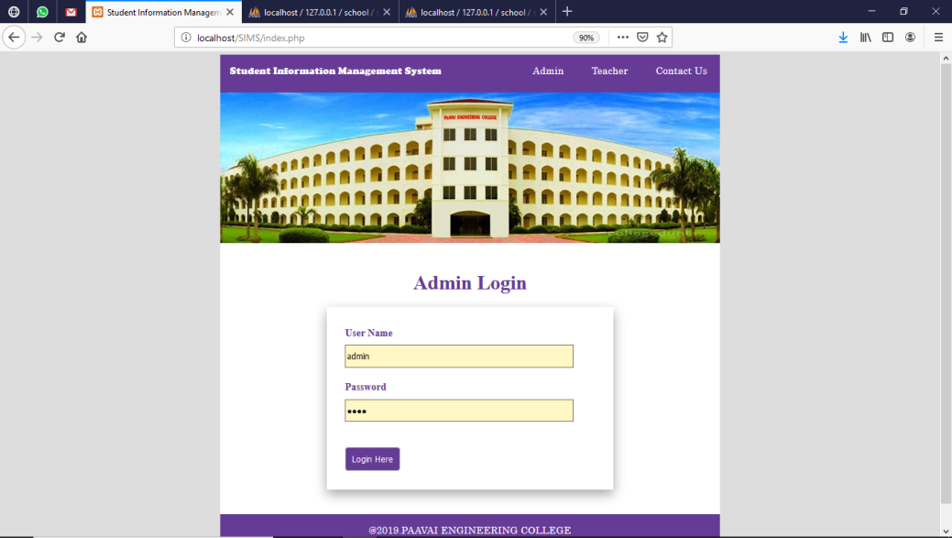

**Description:**

Here user gives their username and password to login in to the Adminstrator Screen.

**Admin home page**

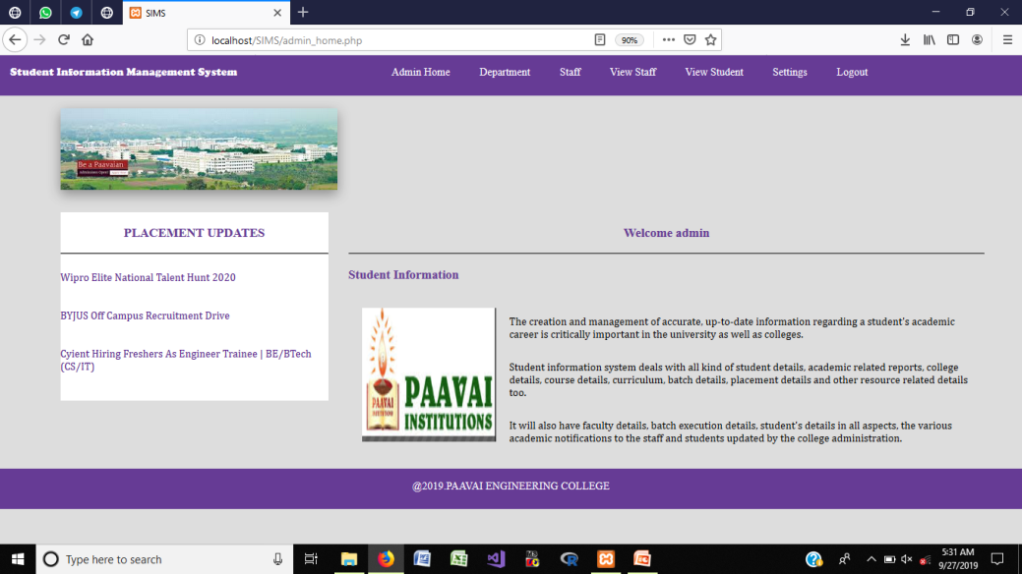

**Description:**

Here admin can give the placement updates for the students day by day.

**Add Department**

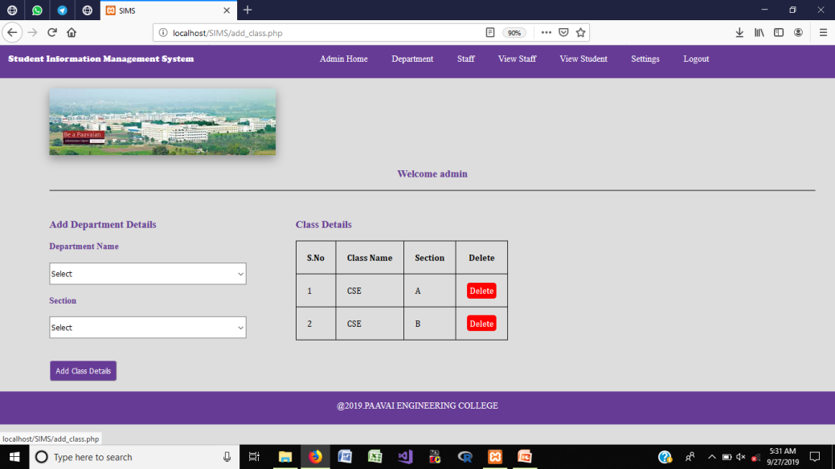

**Description:**

Here admin can add new department details and can delete if it is unnecessary.

**View Student**

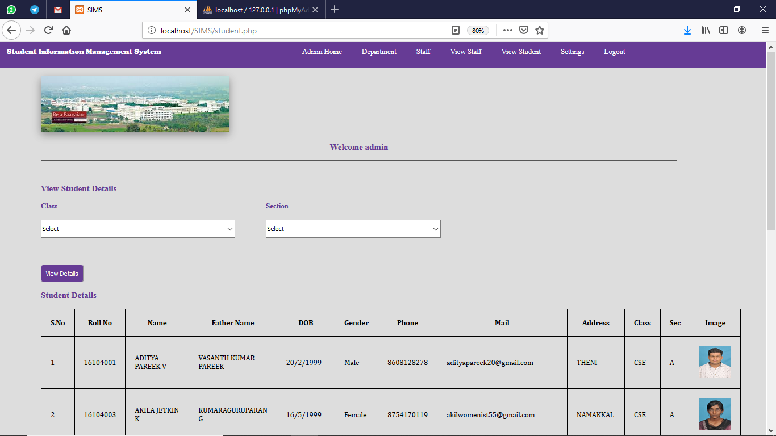

**Description:**

Here admin can see the student’s details by selecting the required department

**Staff Login Page**

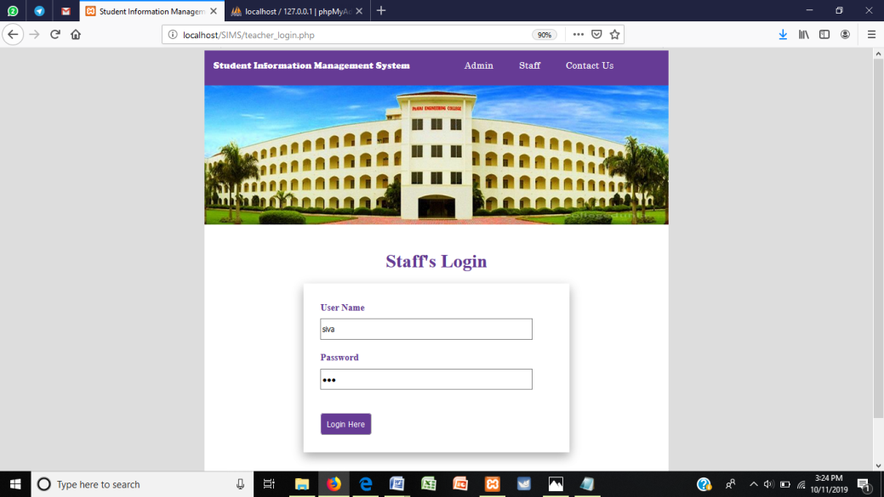

**Description:**

Here user gives their username and password to login in to the Staff Screen.

**Staff Profile**

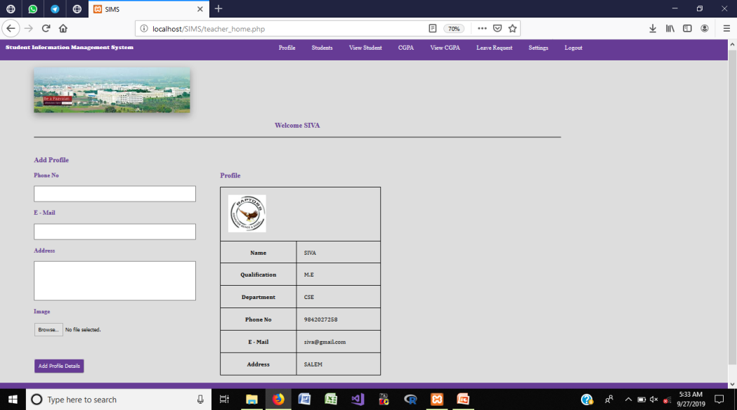

**Description:**

Here user can update their profile like phone number,email id and image.

**Add Students details**

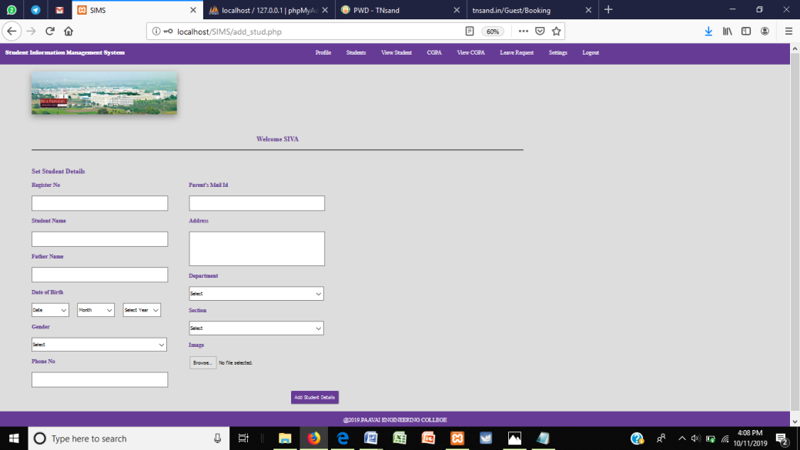

**Description:**

Here user can add students details by giving basic details and by clicking add button, the details will store in the database.

**Apply Leave**

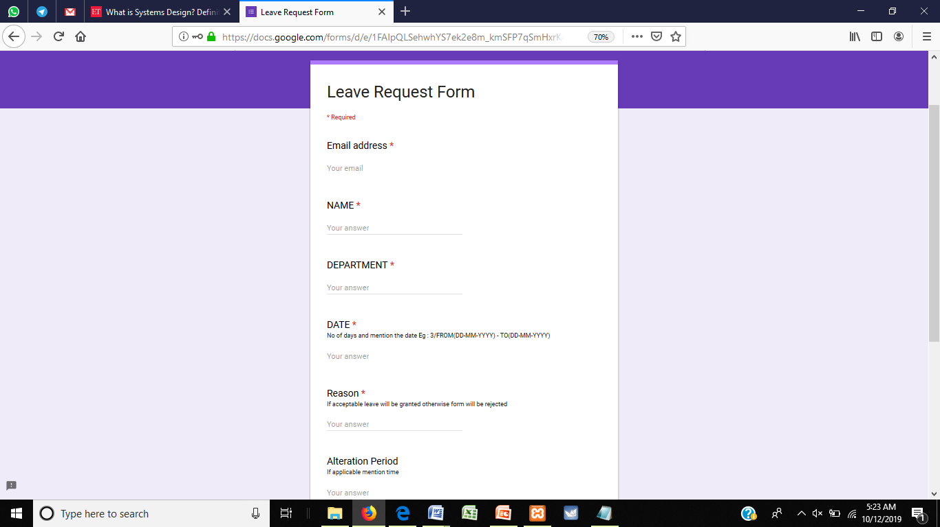

**Description:**

Here user can apply the leave request through Google form which is been linked to their login.

**View CGPA**

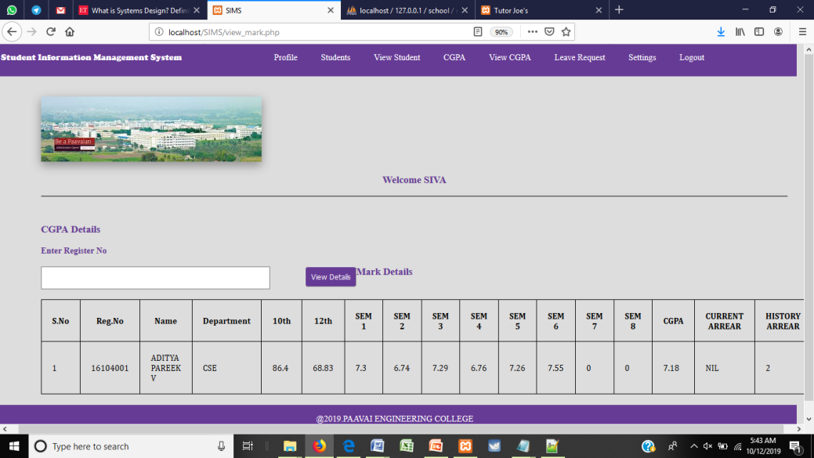

**Description:**

Here user can view the student’s academic performance by semester wise and it’s including the arrear counts of the students.

**Change Password**

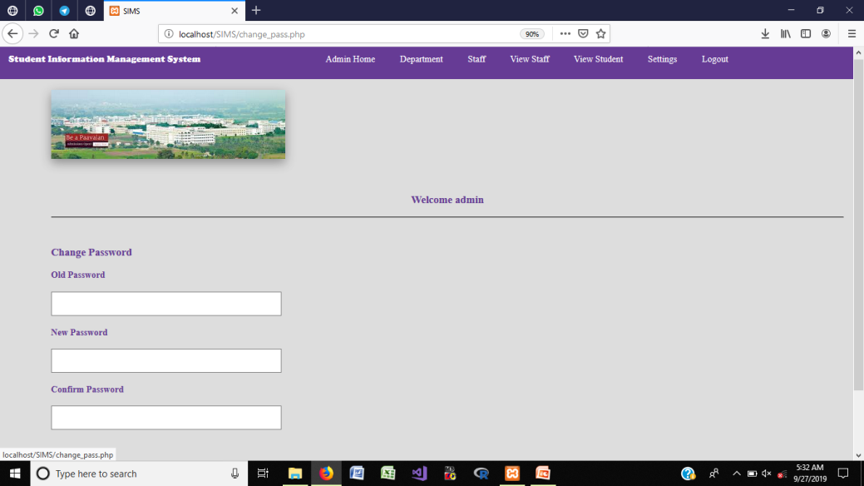

**Description:**

Here users can change password by entering the old password to the new password.

**CHAPTER 7**

**CONCLUSION AND FUTURE ENHANCEMENT**

**7.1 CONCLUSION**

A web application for Students Information Management is developed. This application offers reliability and it is easy to monitor. It can be implemented in all educational institutions to maintain the student’s data. It gathers the data of the student and easy to sort list the members at the time of placement time. In proposed system it will be easier to process the student’s data to current update. Its works systematically and will make ease the user in order to manage all the student data in the system. This system will give a better performance in arranging the lecturer and student information without having to do it manually. This system will help faculty to arrange student data and schedule faster and easier.

**7.2 FUTURE ENHANCEMENT**

In future it can be implemented with additional student data with the strength of whole institution. Since it is a web based application anyone can use the system anywhere at any time and it is very easy to get the necessary information without latency. It can be enhanced to get their report on attendance and internal assessments. Information about student’s academic performance to their parents via SMS and mail can be added in future. Since this application is handled by the college, any upgradation of the system will be with only the addition of module cost without the upfront investment, and the system will be more secure when it is handled by granted users who have the privilege.

**APPENDIX**

**CODING**

**Admin Login**

<?php

include"database.php";

session_start();

?>

<!DOCTYPE html>

<html>

<head>

<title>Student Information Management System</title>

<link rel="stylesheet" type="text/css" href="css/style.css">

</head>

<body class="back">

<?phpinclude"navbar.php";?>

<imgsrc="img/b1.jpg" width="800">

<div class="login">

<h1 class="heading">Staff's Login</h1>

<div class="log">

<?php

if(isset($_POST["login"]))

{

$sql="select * from staff where TNAME='{$_POST["name"]}'and TPASS='{$_POST["pass"]}'";

$res=$db->query($sql);

if($res->num_rows>0)

{

$ro=$res->fetch_assoc();

$_SESSION["TID"]=$ro["TID"];

$_SESSION["TNAME"]=$ro["TNAME"];

echo "<script>window.open('teacher_home.php','_self');</script>";

}

else

{

echo "<div class='error'>Invalid Username Or Password</div>";

}

}

?>

<form method="post" action="<?php echo $_SERVER["PHP_SELF"];?>">

<label>User Name</label><br>

<input type="text" name="name" required class="input"><br><br>

<label>Password </label><br>

<input type="password" name="pass" required class="input"><br>

<button type="submit" class="btn" name="login">Login Here</button>

</form>

</div>

</div>

<div class="footer">

<footer><p>@2019.PAAVAI ENGINEERING COLLEGE </p></footer>

</div>

<scriptsrc="js/jquery.js"></script>

<script>

$(document).ready(function(){

$(".error").fadeTo(1000, 100).slideUp(1000, function(){

$(".error").slideUp(1000);

});

$(".success").fadeTo(1000, 100).slideUp(1000, function(){

$(".success").slideUp(1000);

});

});

</script>

</body>

</html>

**Staff Login**

<?php

include"database.php";

session_start();

?>

<!DOCTYPE html>

<html>

<head>

<title>Student Information Management System</title>

<link rel="stylesheet" type="text/css" href="css/style.css">

</head>

<body class="back">

<?phpinclude"navbar.php";?>

<imgsrc="img/b1.jpg" width="800">

<div class="login">

<h1 class="heading">Staff's Login</h1>

<div class="log">

<?php

if(isset($_POST["login"]))

{

$sql="select * from staff where TNAME='{$_POST["name"]}'and TPASS='{$_POST["pass"]}'";

$res=$db->query($sql);

if($res->num_rows>0)

{

$ro=$res->fetch_assoc();

$_SESSION["TID"]=$ro["TID"];

$_SESSION["TNAME"]=$ro["TNAME"];

echo "<script>window.open('teacher_home.php','_self');</script>";

}

else

{

echo "<div class='error'>Invalid Username Or Password</div>";

}

}

?>

<form method="post" action="<?php echo $_SERVER["PHP_SELF"];?>">

<label>User Name</label><br>

<input type="text" name="name" required class="input"><br><br>

<label>Password </label><br>

<input type="password" name="pass" required class="input"><br>

<button type="submit" class="btn" name="login">Login Here</button>

</form>

</div>

</div>

<div class="footer">

<footer><p>@2019.PAAVAI ENGINEERING COLLEGE </p></footer>

</div>

<scriptsrc="js/jquery.js"></script>

<script>

$(document).ready(function(){

$(".error").fadeTo(1000, 100).slideUp(1000, function(){

$(".error").slideUp(1000);

});

$(".success").fadeTo(1000, 100).slideUp(1000, function(){

$(".success").slideUp(1000);

});

});

</script>

</body>

</html>

**Student**

<?php

include"database.php";

session_start();

if(!isset($_SESSION["AID"]))

{

echo"<script>window.open('index.php?mes=Access Denied...','_self');</script>";

}

?>

<!DOCTYPE html>

<html>

<head>

<title>SIMS</title>

<link rel="stylesheet" type="text/css" href="css/style.css">

</head>

<body>

<?phpinclude"navbar.php";?><br>

<imgsrc="img/1.jpg" style="margin-left:90px;" class="sha"><br><br>

<div id="section">

<h3 class="text">Welcome <?php echo $_SESSION["ANAME"]; ?></h3><br><hr><br>

<div class="content">

<h3 >View Student Details</h3><br>

<form method="post" action="<?php echo $_SERVER["PHP_SELF"];?>">

<div class="lbox1">

<label>Class</label><br>

<select name="cla" required class="input3">

<?php

$sl="SELECT DISTINCT(CNAME) FROM class";

$r=$db->query($sl);

if($r->num_rows>0)

{

echo"<option value=''>Select</option>";

while($ro=$r->fetch_assoc())

{

echo "<option value='{$ro["CNAME"]}'>{$ro["CNAME"]}</option>";

}

}

?>

</select>

<br><br>

</div>

<div class="rbox">

<label>Section</label><br>

<select name="sec" required class="input3">

<?php

$sql="SELECT DISTINCT(CSEC) FROM class";

$re=$db->query($sql);

if($re->num_rows>0)

{

echo"<option value=''>Select</option>";

while($r=$re->fetch_assoc())

{

echo "<option value='{$r["CSEC"]}'>{$r["CSEC"]}</option>";

}

}

?>

</select><br><br>

</div>

<button type="submit" class="btn" name="view"> View Details</button>

</form>

<br>

<div class="Output">

<?php

if(isset($_POST["view"]))

{

echo "<h3>Student Details</h3><br>";

$sql="select * from student where SCLASS='{$_POST["cla"]}' and SSEC='{$_POST["sec"]}'";

$re=$db->query($sql);

if($re->num_rows>0)

{

echo '

<table border="1px">

<tr> <th>S.No</th> <th>Roll No</th> <th>Name</th>

<th>Father Name</th>

<th>DOB</th>

<th>Gender</th>

<th>Phone</th>

<th>Mail</th>

<th>Address</th>

<th>Class</th>

<th>Sec</th>

<th>Image</th>

</tr>

';

$i=0;

while($r=$re->fetch_assoc())

{

$i++;

echo "

<tr>

<td>{$i}</td>

<td>{$r["RNO"]}</td>

<td>{$r["NAME"]}</td>

<td>{$r["FNAME"]}</td>

<td>{$r["DOB"]}</td>

<td>{$r["GEN"]}</td>

<td>{$r["PHO"]}</td>

<td>{$r["MAIL"]}</td>

<td>{$r["ADDR"]}</td>

<td>{$r["SCLASS"]}</td>

<td>{$r["SSEC"]}</td>

<td><imgsrc='{$r["SIMG"]}' height='70' width='70'></td>

</tr>

";

}

}

else

{

echo "No record Found";

}

echo "</table>";

}

?>

</div>

</div>

</div>

<?phpinclude"footer.php";?>

</body>

</html>

**REFERENCES**

[1] N.M.Z.Hashim, S.N.K.S.Mohamed, ”Development of Student Information System” International Journal of Science and Research (IJSR), Vol. 2, Issue 8, August 2013.

[2] S.R.Bharamagoudar, Geeta R.B., S.G.Totad, “Web Based Student Information Management System” International Journal of Advanced Research in Computer and Communication Engineering, Vol. 2, Issue 6, June 2013.

[3] Saurabh Walia1, SatinderjitKaur Gill, “A Framework for Web Based Student Record Management System using PHP” International Journal of Computer Science and Mobile Computing (IJCSMC), Vol. 3, Issue. 8, August 2014.

[4] Manisha K, Alekhya K, T Manikanta, B Ramya, S. Sai Kumar, “Student Information Management System” International Journal of Advanced Research in Computer Science and Software Engineering,Volume 6, Issue 3, March 2016.

[5] Krithi P, Dr M Ramakrishna, “Student Management System – A Survey” International Research Journal of Computer Science (IRJCS) Issue 05, Volume 4 (May 2017).